Installing Eclipse for DeepskyLog development

1. Pre-installation

- Download and **install Java 6** from <http://java.sun.com/javase/downloads/index.jsp> (**Select Java Runtime Environment** (JRE) 6 Update xx)

- **Download eclipse** inclusive all **packages for php development** from <http://www.eclipse.org/downloads/>

- Unzip the file and start eclipse

1. Installation

- Choose a new directory for the workspace, and confirm your choice

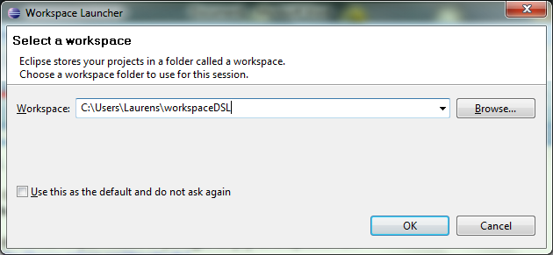

- You should now see the eclipse welcome screen

* 1. 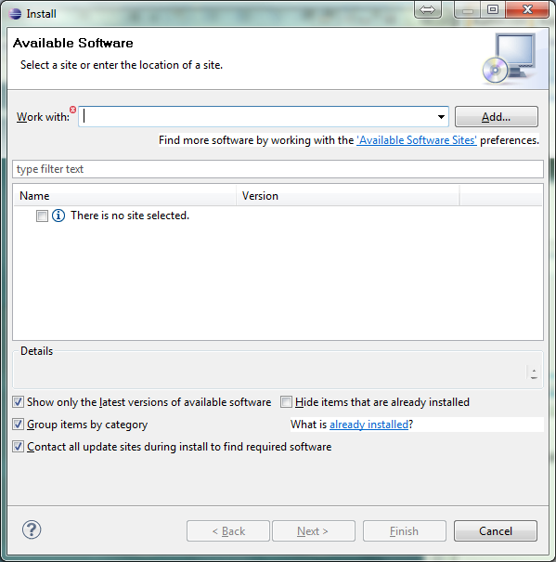Installation of bugzilla connector

- In the menubar, navigate to ‘Help’ => ‘Install new software’

- Click the ‘Add’ button in the upper right corner of the window

- Add the following site, and click the OK button:

Helios Discovery site, Location:  http://download.eclipse.org/releases/helios/

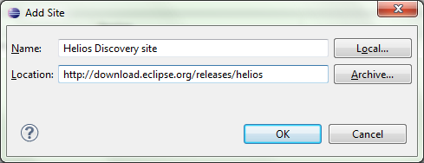

- Wait for eclipse to look up the available software packages

- Next, under “Collaboration”, select ‘Mylyn Bridge: Eclipse IDE‘, ‘Mylyn Connector: Bugzilla’, ‘Mylyn Task-Focused Interface’ and ‘Mylyn Task List’

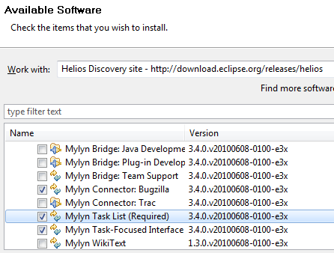

- Now click the Next button and complete the installation

* 1. Installation of subversive client

- In the menubar, navigate to ‘Help’ => ‘Install new software’

- Click the ‘Add’ button in the upper right corner of the window

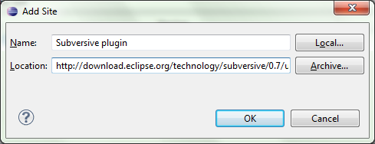

- Add the following two sites using this method (you can also enter the URL in the “Work with” bar):

- Name: Subversive plugin

URL: <http://download.eclipse.org/technology/subversive/0.7/update-site/>

* Name: Subversive connectors

URL: <http://www.polarion.org/projects/subversive/download/eclipse/2.0/update-site/>

- From these two different sites, now install:

1) Subversive SVN Team Provider (Incubation) 0.7.3

2) Optionally: Subversive SVN Integration for the Mylyn project)

3) Install, and restart Eclipse

4) Install native JavaHL 1.5 Implementation. Continue to install . When prompted to install optional packages, install them all.

🡺 You can select to search at “All available sites” on top of the window, and then enter a filter text to find the software you need to install

1. Adding the project to the workspace

Now we can add the project to our workspace.

In the menu, choose File => New => Other

In the category “SVN”, choose “Project from SVN”

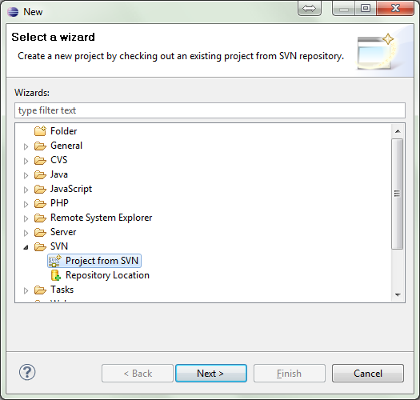

- Click Next

- The following window will appear:

- Enter the following URL:

<http://subversion.deepskylog.org/repos/deepskylog/>

- Also enter your subversion username and password

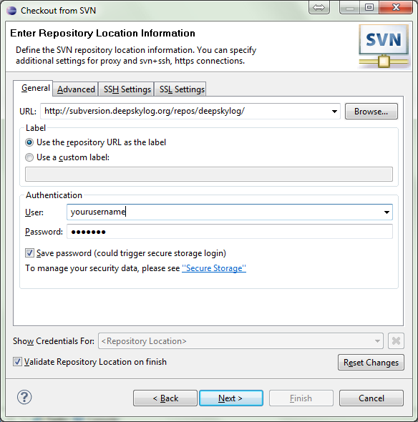

- Now click “Next”

- In the next step, click the **Browse** button

Now select **Trunk** or **Tags => [version number]** depending on which source files you wish to retrieve.

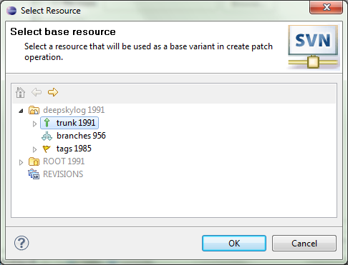In this example, we select **Trunk**.

Click the “OK” button and afterwards the “Finish button”.

Check out as a project configured using the New Project Wizard

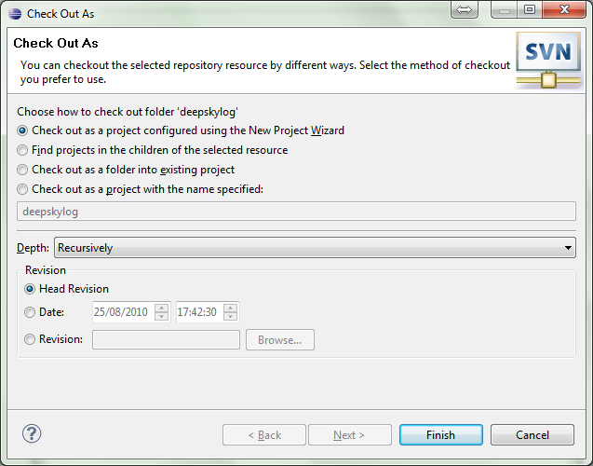

Now click the **Finish** button, and sselect **PHP** => **PHP Project**

Enter a name for the project, and click **Next,** select your source folder, and click **Finish**.

**\* If you already installed** **a local testing server, you can select a new subdirectory of your www directory  
* If you do not have a testing server yet, and you plan on running multiple projects on your testing server, you can extract to e.g. c:\wamp\www\DSL\. If you do so, you will have to create those 3 folders. If you create this folders, remember to use the default installation folder in chapter IV of this guide.**

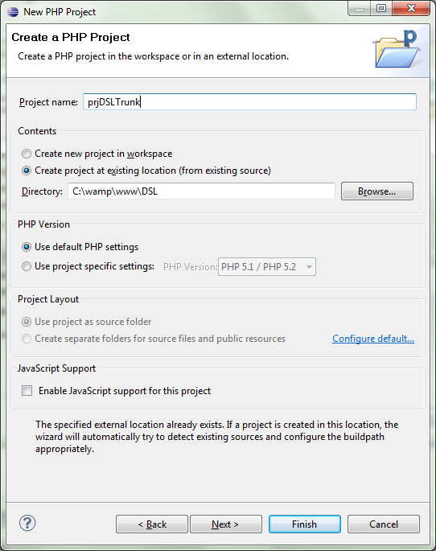

Click “Finish”. The source files will now be retrieved.

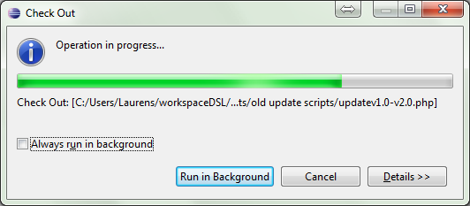

III. Configure Task List (optional)

If you want Eclipse to automatically retrieve the bug list, then follow these

Instructions

- In the menu, select Window => Show view => Task list

- In the right panel, the ‘Task List’ panel will now appear

- Right click a blank part of the panel, and select New => Query

- Click “Add Task Repository”

- Select Bugzilla, click next

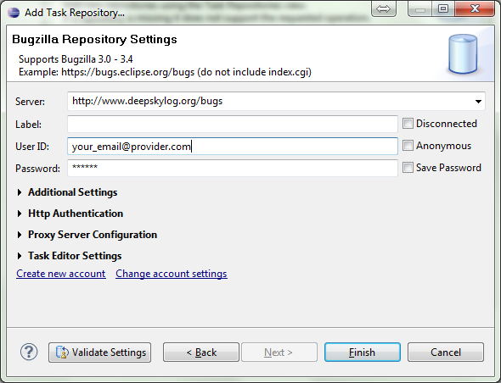

Enter the server **http://www.deepskylog.org/bugs** and your Bugzilla User ID and Password.

- Click Finish

- Now select the deepskylog repository we just added, and click Next

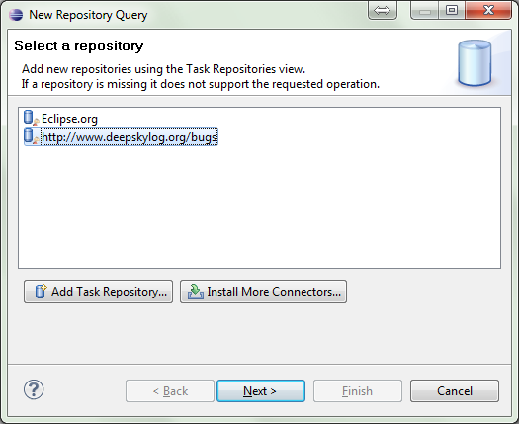

- Select to create the query using a form

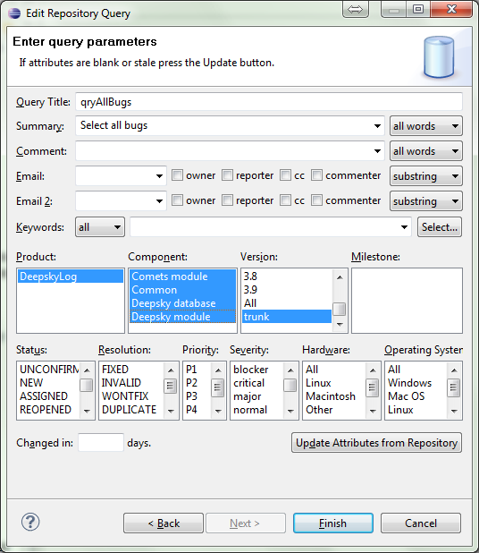

- Enter the selection criteria you need, and click “Finish”. Do not forget to enter a name for your query

- Now the tasks will appear in the task list (most right part of the window). It may be necessary to double click the query name in order to see all tasks. Double clicking the task will open up a form you can edit. After saving, the bugzilla entry will be adapted.

IV. Testing your changes under Windows

In orde to be able to test your changes, you need a local testing server.

In this example, we will use WampServer 2 which allows quick configuration of Apache, MySQL and PHP.

Download the software from <http://www.wampserver.com/>

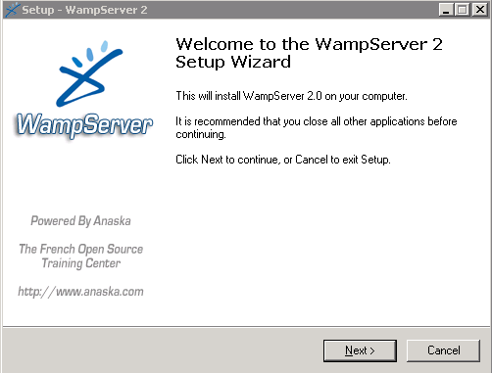

Complete this installation wizard. At the end of the wizard, tick the checkbox to start WampServer now.

- Verify that your installation is working at <http://127.0.0.1/>. You should see a page with the WampServer logo.

- In Eclipse, in the PHP Explorer window: right click the project name, and choose “properties”. You will see the location where the project is stored. Copy it to the clipboard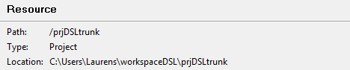.

Changing the www folder (not necessary if you extracted to www folder)

- Now we need to modify Apache’s configuration so that this folder is used as the default www folder.

In your system tray, click the Wamp icon , and choose to “Stop all services”

- Now open the file \wamp\bin\apache\Apache2.2.11\conf\httpd.conf

- Around line 205, you will see a line with the following contents:

<Directory "c:/wamp/www/">

- Change the directory between the quotes to the directory you copied to the clipboard. Note that the backslashes should be changed to forward slashes

- Do the same for DocumentRoot around line 178.

- Save and close the file. Now click the Wamp icon in the system tray again, and choose to “Start all services”.

Importing the database

- Now you need to import the SQL dumps in the sql folder. You can either do this using the mysql prompt or in phpMyAdmin.

Go to <http://127.0.0.1/phpmyadmin/> and create a database called “deepskylog”

Open a command prompt

Using the CD command, navigate to \wamp\bin\mysql\mysql5.1.36\bin\

Now use the following command to import the database dumps:

* **mysql -u username -p password database_name < dump.sql**

- Replace “dump.sql” by the path to the SQL file.

- In wamp, the username is by default “root”, and the password is left blank.

- You need to adapt the database credentials at /lib/setup/databaseInfo.php.dist

- Also set $instDir and $baseURL to their correct values. Remember to use forward slashes

- Remove the .dist file extension by renaming the file.

You should now have a working version of deepskylog at <http://127.0.0.1/>.

If you wish to use your testing servers for other purposes, too, you can setup symlinks in httpd.conf, which is not covered in this document.

V. Setting up Eclipse to interpret other file extensions as PHP

In DeepskyLog, some non-standard file extensions are used. For example, the ICQ extension.

Below is shown how to setup Eclipse to parse these files as PHP, too, so that syntax highlighting will be activated.

- In the menu, click “Window” => “Preferences”. In the left column, select “General” => “Content types”

- In the right hand part of the window, expand the group “Text”, and select “PHP Content Type”. Click the “Add” button.

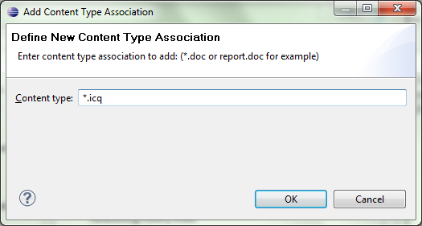

Enter the custom extension, and click the OK button.

Now click  on top of the window.



Then click the “Add“ button, and again add your custom extension, for example “*.icq” . Confirm by clicking the OK button. The PHP Editor and Text Editor should now be automatically associated with the new file type